DockerDay-5

Mrng-Docker-compose,OverView

Docker-compose is used to launch the multiple containers at a single command “docker-compose up –d"

So this can be possible by using yaml files where we mention the all the properties for the contaners

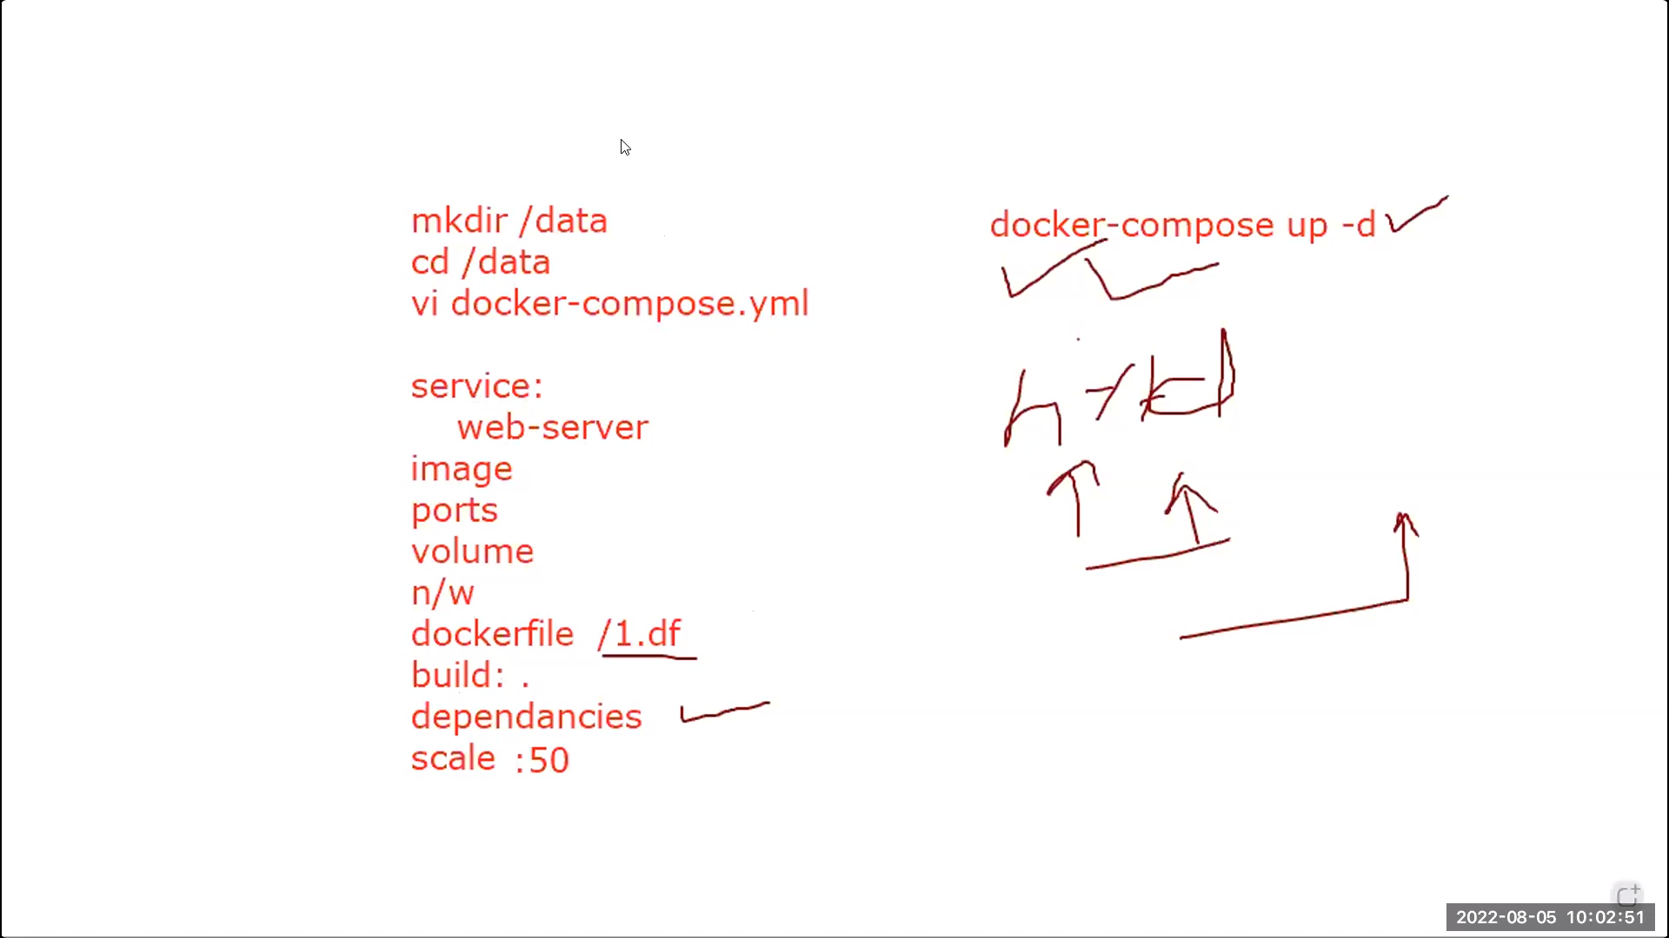below image for space indendtation for yaml files

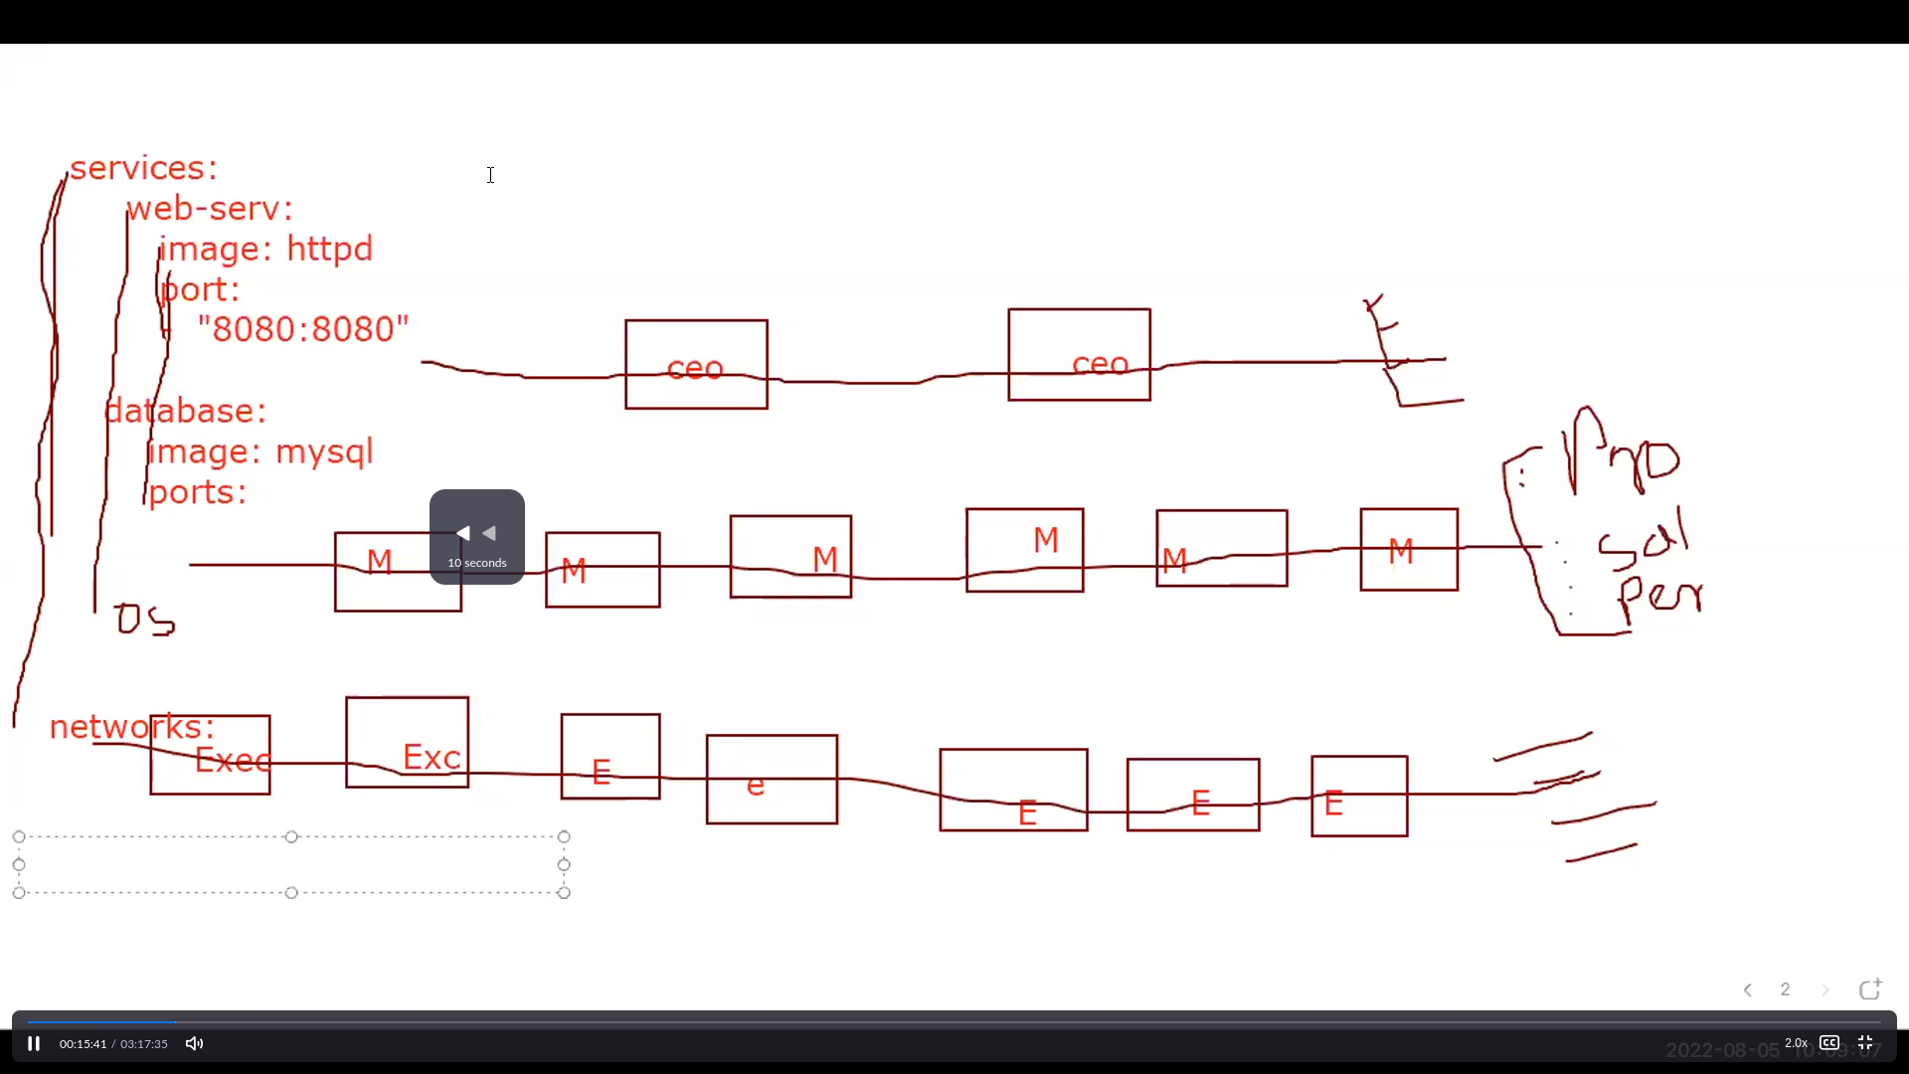

Docker-compose installation:

sudo curl -L https://github.com/docker/compose/releases/latest/download/docker-compose-$(uname -s)-$(uname -m) -o /usr/local/bin/docker-compose  
  
sudo chmod +x /usr/local/bin/docker-compose  
  
docker-compose –version

-----------------------------------------------------------------------------------------------------------------------------------------

Dc1 file

version: "3"

Services:

Web-server:

image: httpd

ports:

- "8080:80"

db-server:

image: redis

Explanation:

Firstline: it is the version which is compatible with the docker-compose,if we don’t mention “3” it takes latest one

Next: services=containers

Next: “web-servers “is one contaier and below are it’s propeties

Next: “db-servers" is “””””””””””””””””””””””

--------------------------------------------------------------------------------------------------------------------------------------------------------------

Commands:

33 mkdir data

34 cd data

35 ls

36 vi dc1.yaml

37 docker-compose config

38 docker-compose up -d

39 docker network ls

41 docker-compose down

43 cat dc1.yaml

44 docker-compose up -d --scale db-server=5

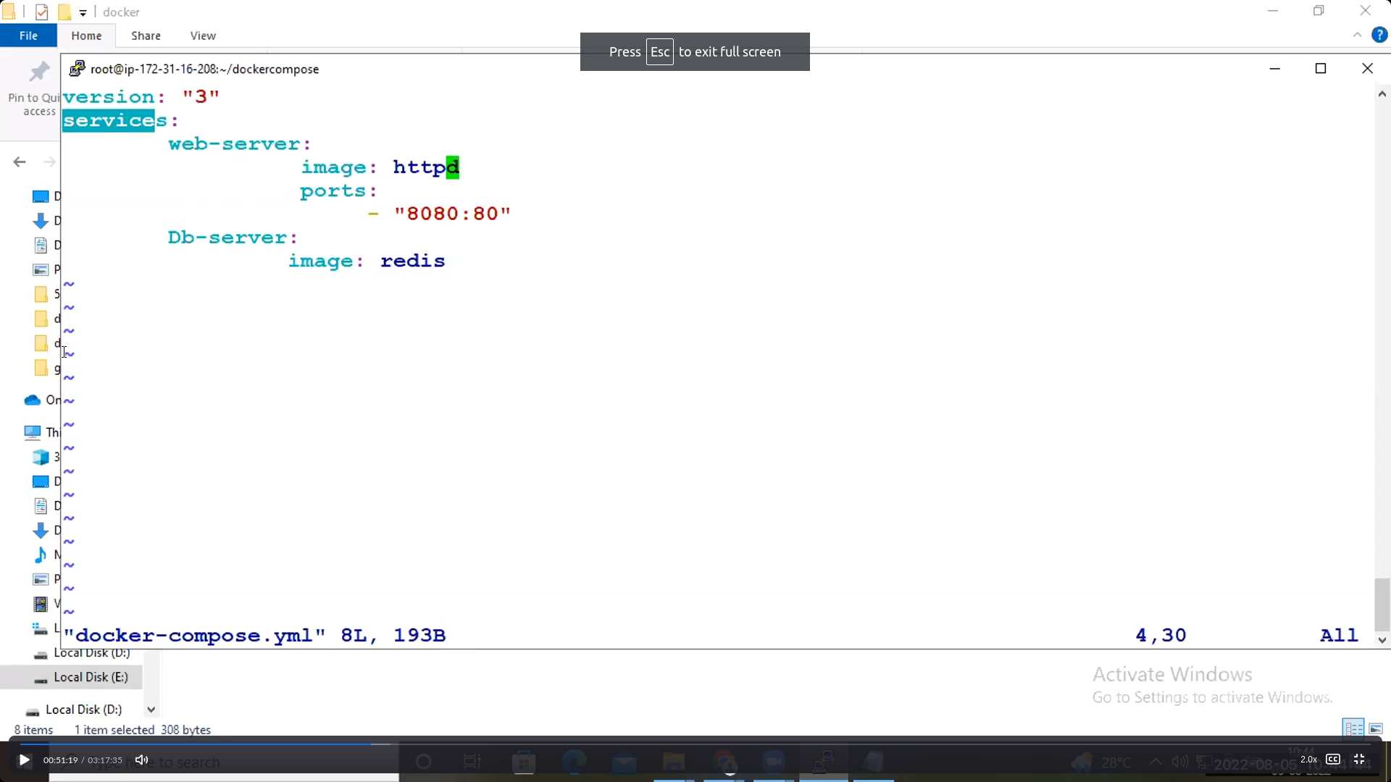

Explanation:

37: it is for dry-run which means it shows the erros

38: it exeecute the files in the data folder

Note: after executing the above command along with the containers one defualt adapter also created

41: viceversa of “38” command it will removes all the properties of previously executed command of dc1.yaml file

Note: after executing the above command along with the containers one defualt adapter also removed

44: it will lauches the 5 containers for db-server

-----------------------------------------------------------------------------------------------------------------------------------

Dc1(a):

version: "3"

Services:

Web-server:

image: httpd

ports:

- "8080:80"

networks:

- "apple"

db-server:

image: redis

networks:

- "orange"

networks:

apple:

orange:

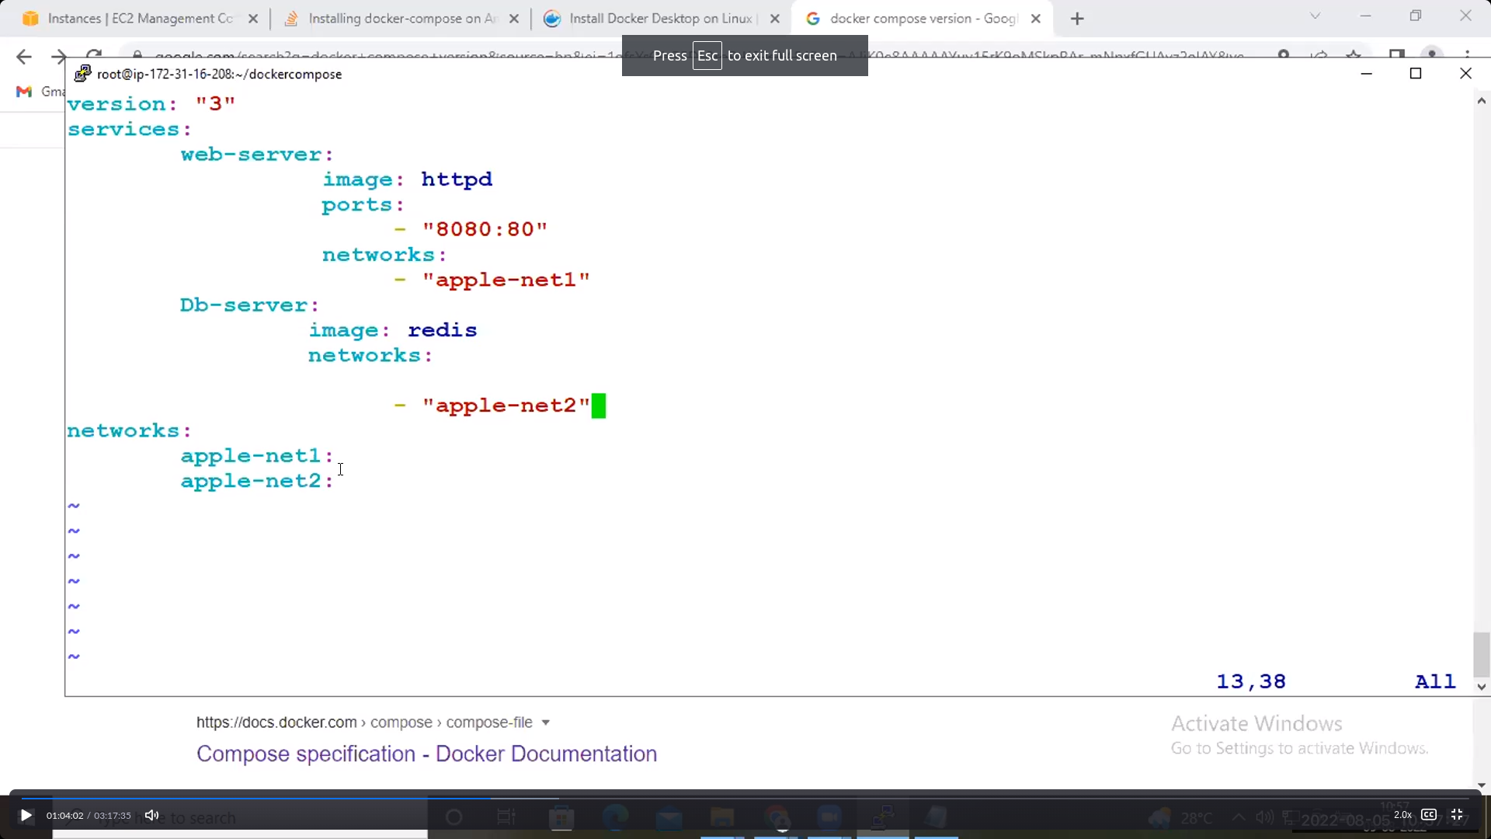

Expalanation:

Last3rdline networks: refers to TWO adapters [ apple, orange]

------------------------------------------------------------------------------------------------------------------------------------

Commands:

46 vi dc1.yaml

47 docker-compose up -d

48 docker network ls

49 docker-compose down

50 docker-compose create

51 docker-network ls

52 docker network ls

53 docker ps

54 docker ps –a

Explanation:

47: above yaml file creates two adapters along with one docker-compose default adapter

50: it will only creates the containers in non-running mode [not even adapters also not created]

**Overview OF Docker:**

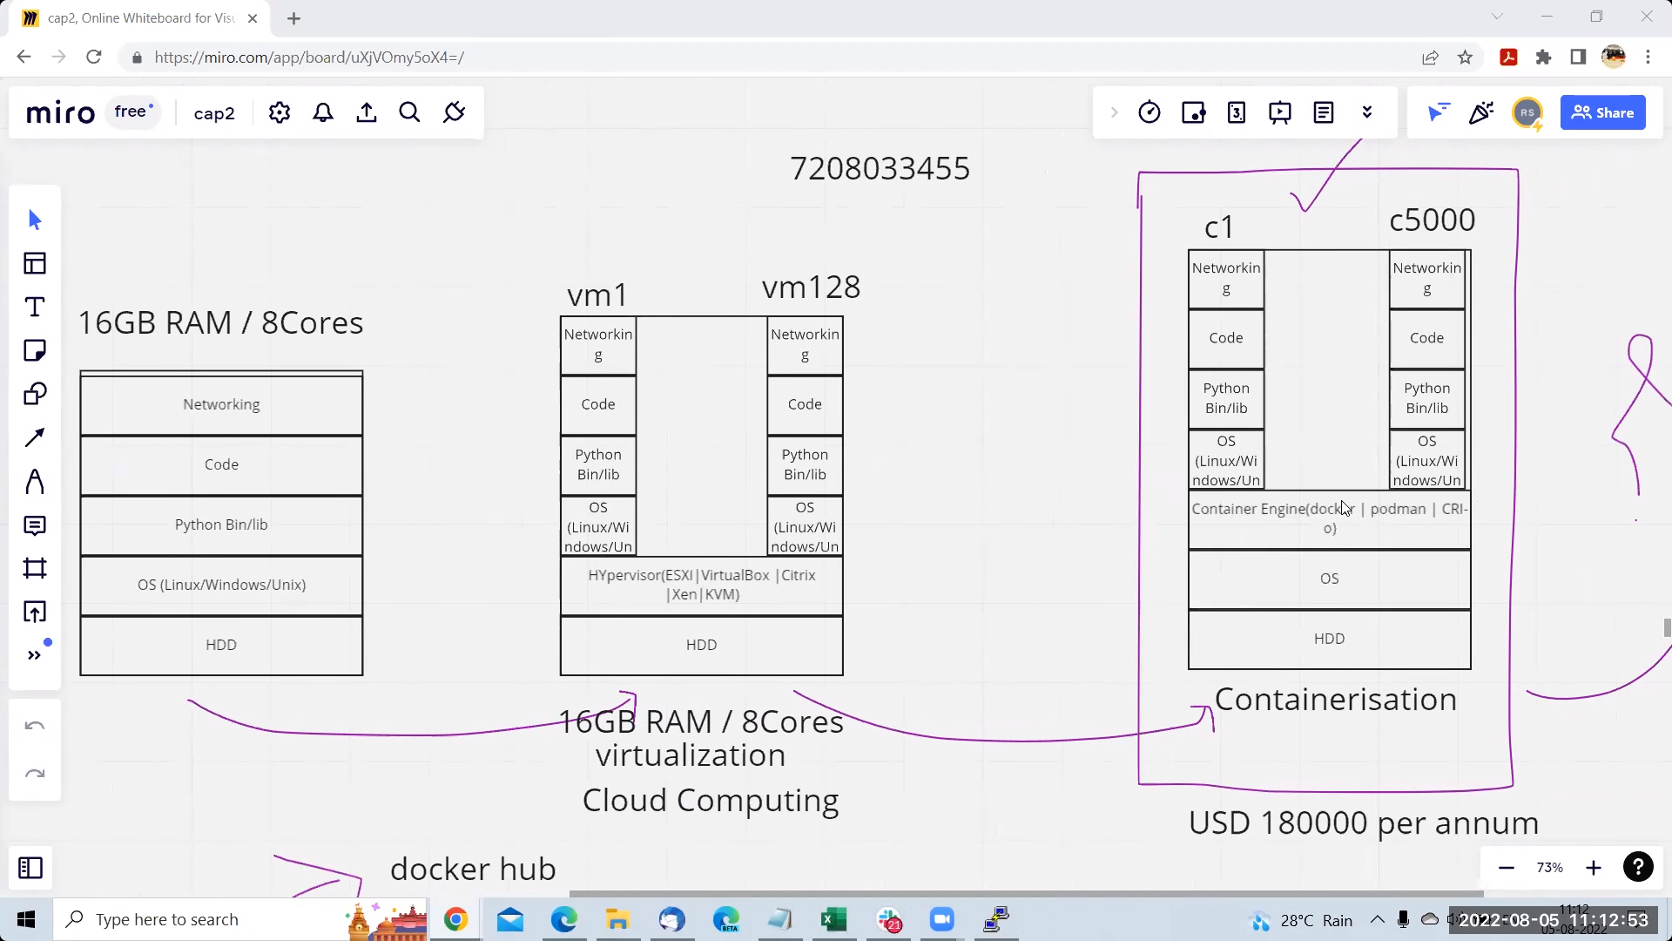

One os one application one hyperiser multiple os and multiple vm’s one os multiple vm’s

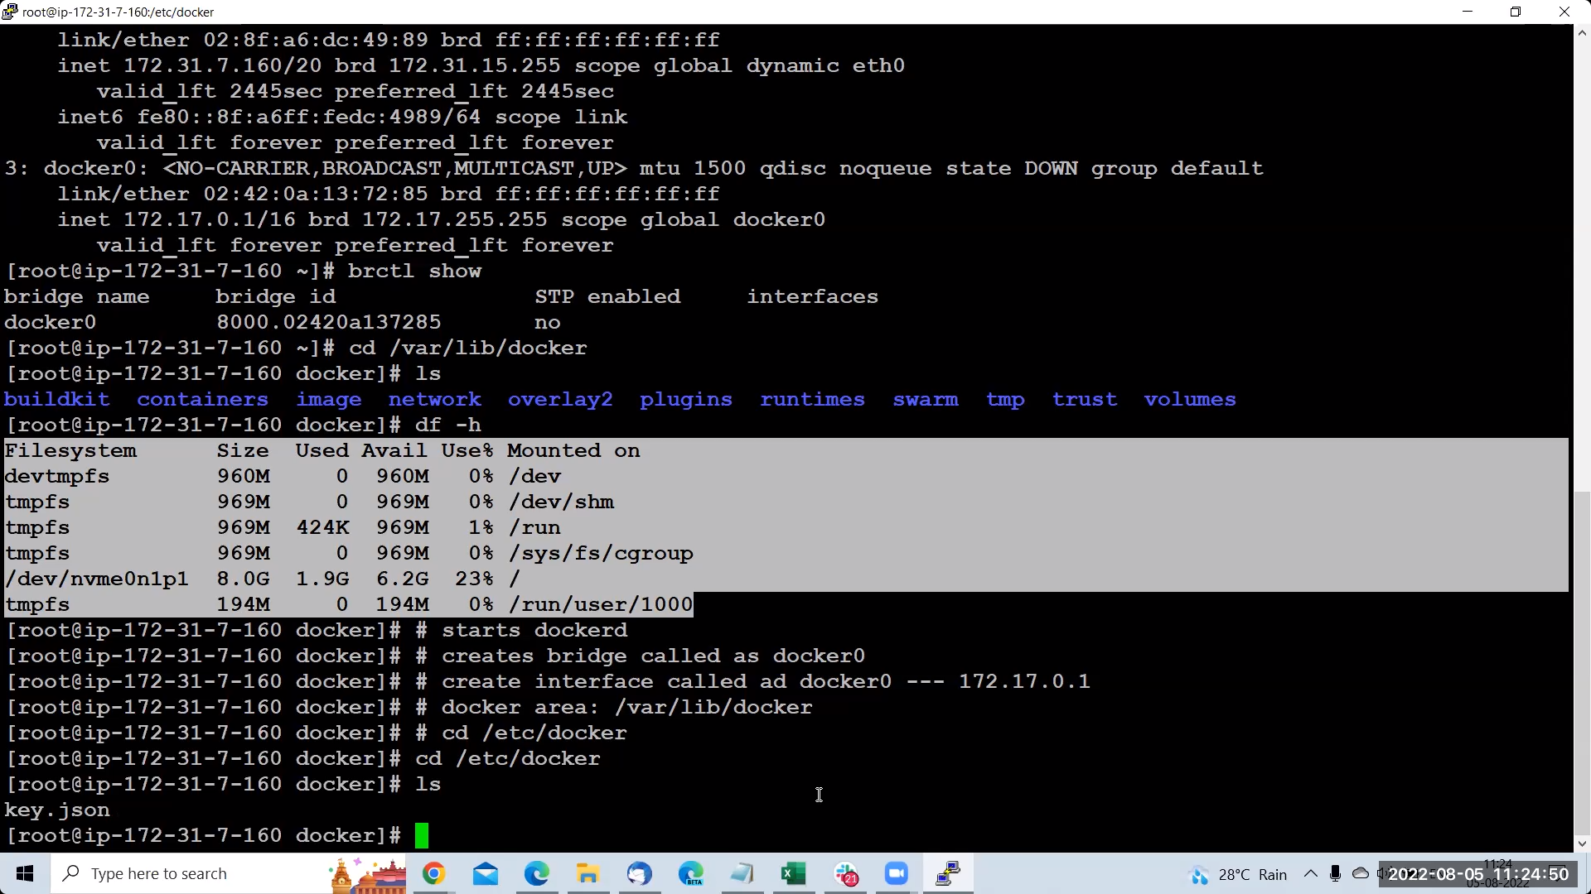

This image shows that container is process not os

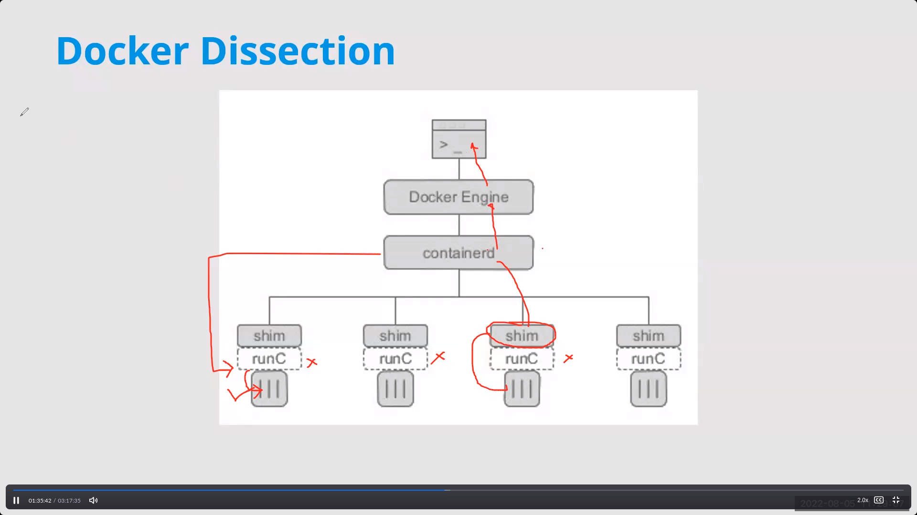

When we exceute the command docker engine[dockerd] handovers the job to containerd so contanerd creates the container using “runc” runc runs the container and kills it’s runc process and creates shim process which handles the container

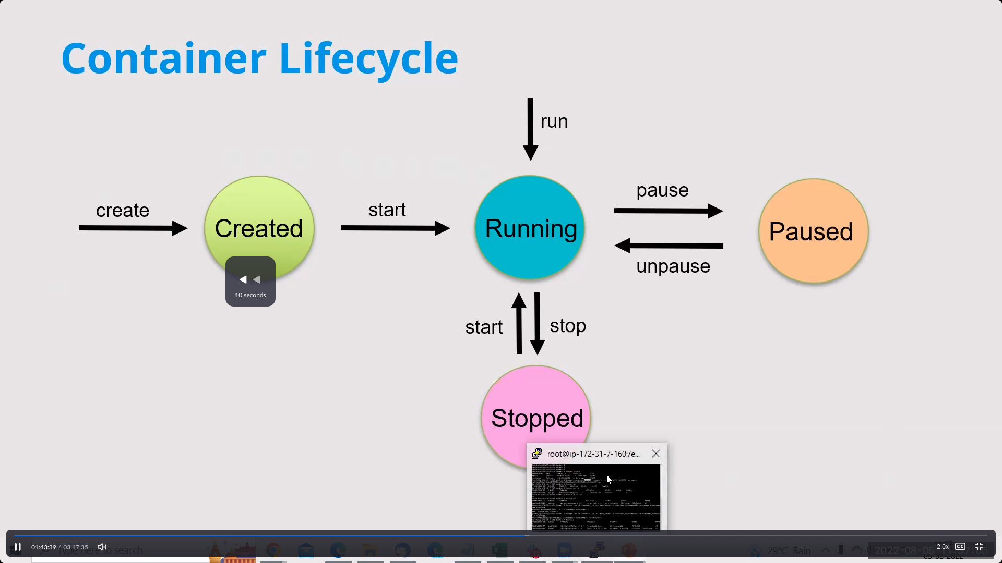

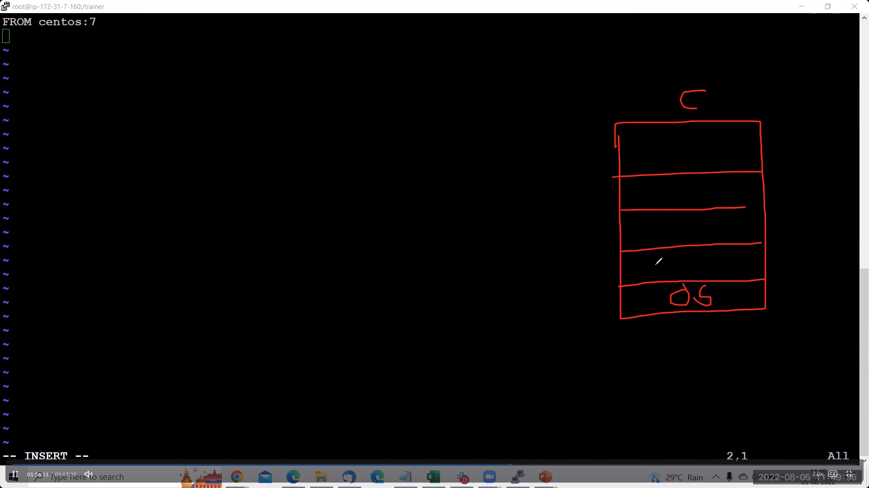

The first command refers that we are pull centos images and above that we are customizes the

Out requirements makes our image

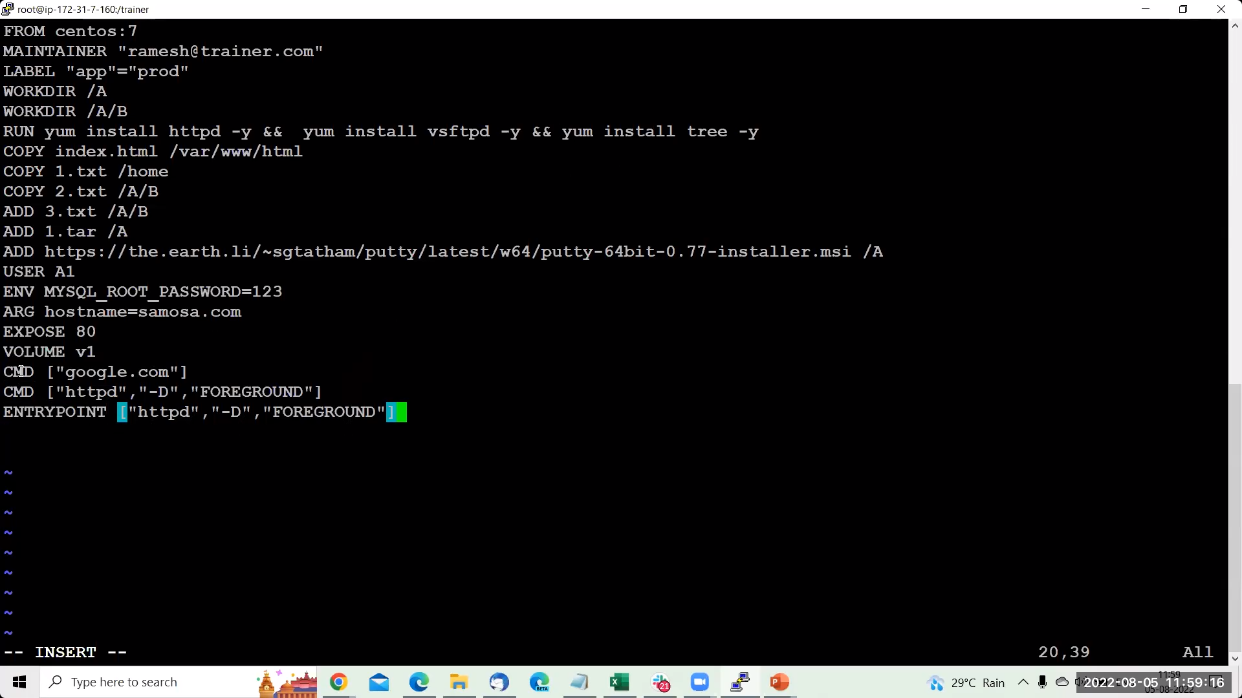Above image shows the dockerfile which contains all commands

ARG :works when image creation

ENV: works when container creation

USER: default is root but if you want create we use this command

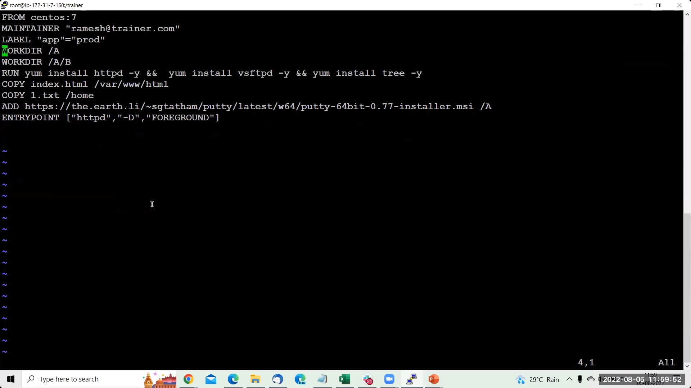

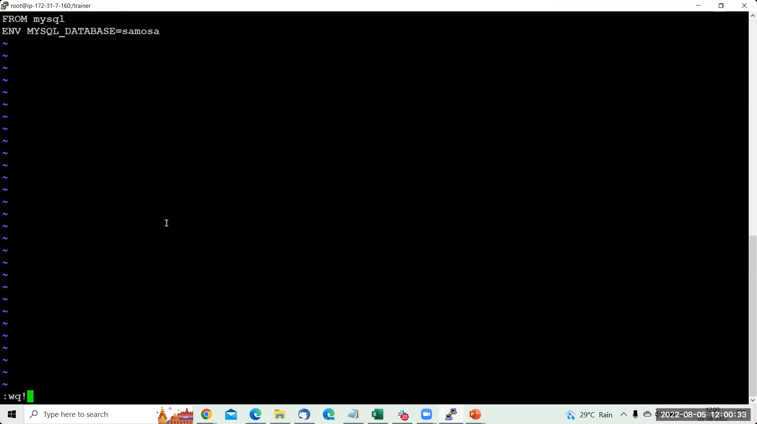

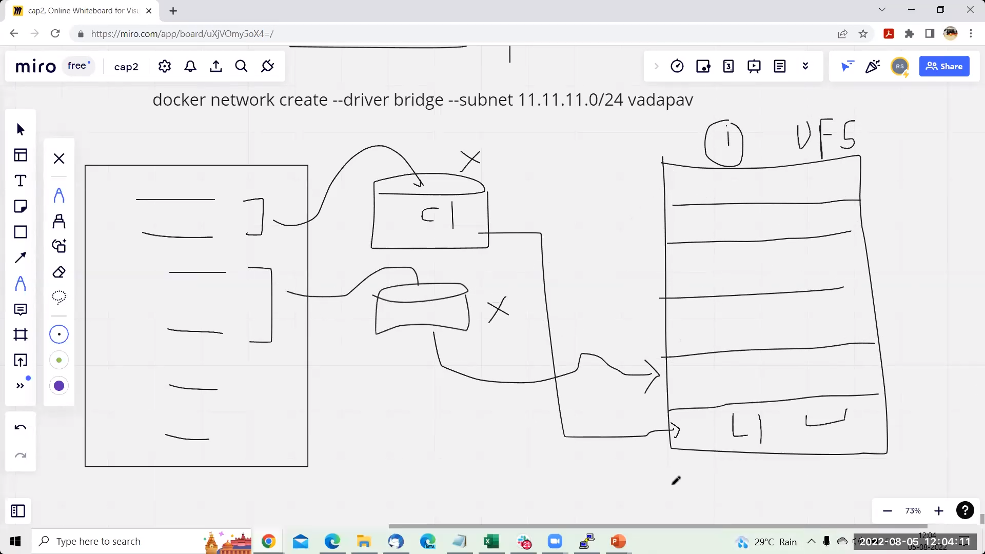

When we run dockerfile which has the command for our own images

It will take some commands and creates the container if it works perfectly then it will goes layer1 for image

In the same way it works all commands

Note: the container which is created is called intermediate container it gets when its layer formed

That image is called as layered structure

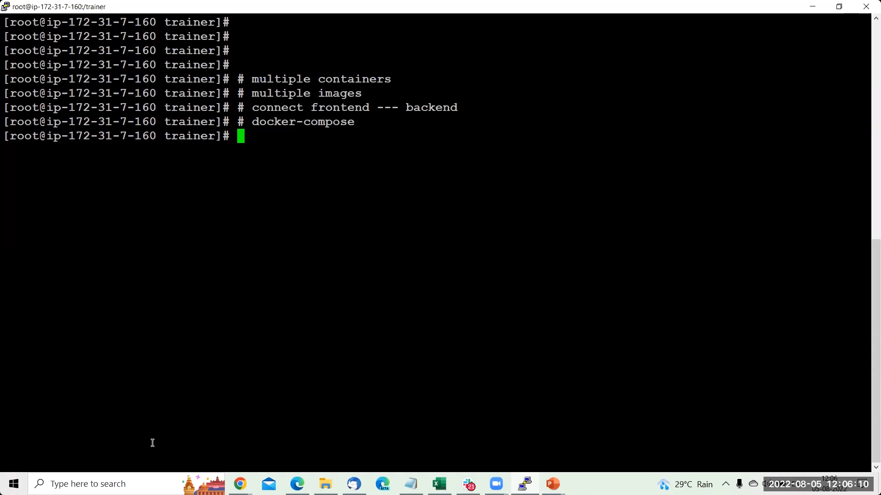

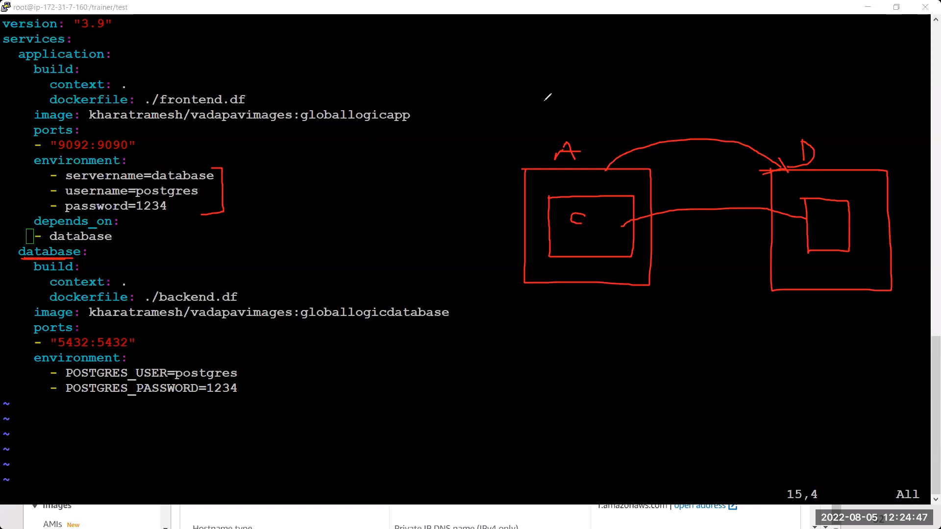

depencency:works for connecting one service to another service

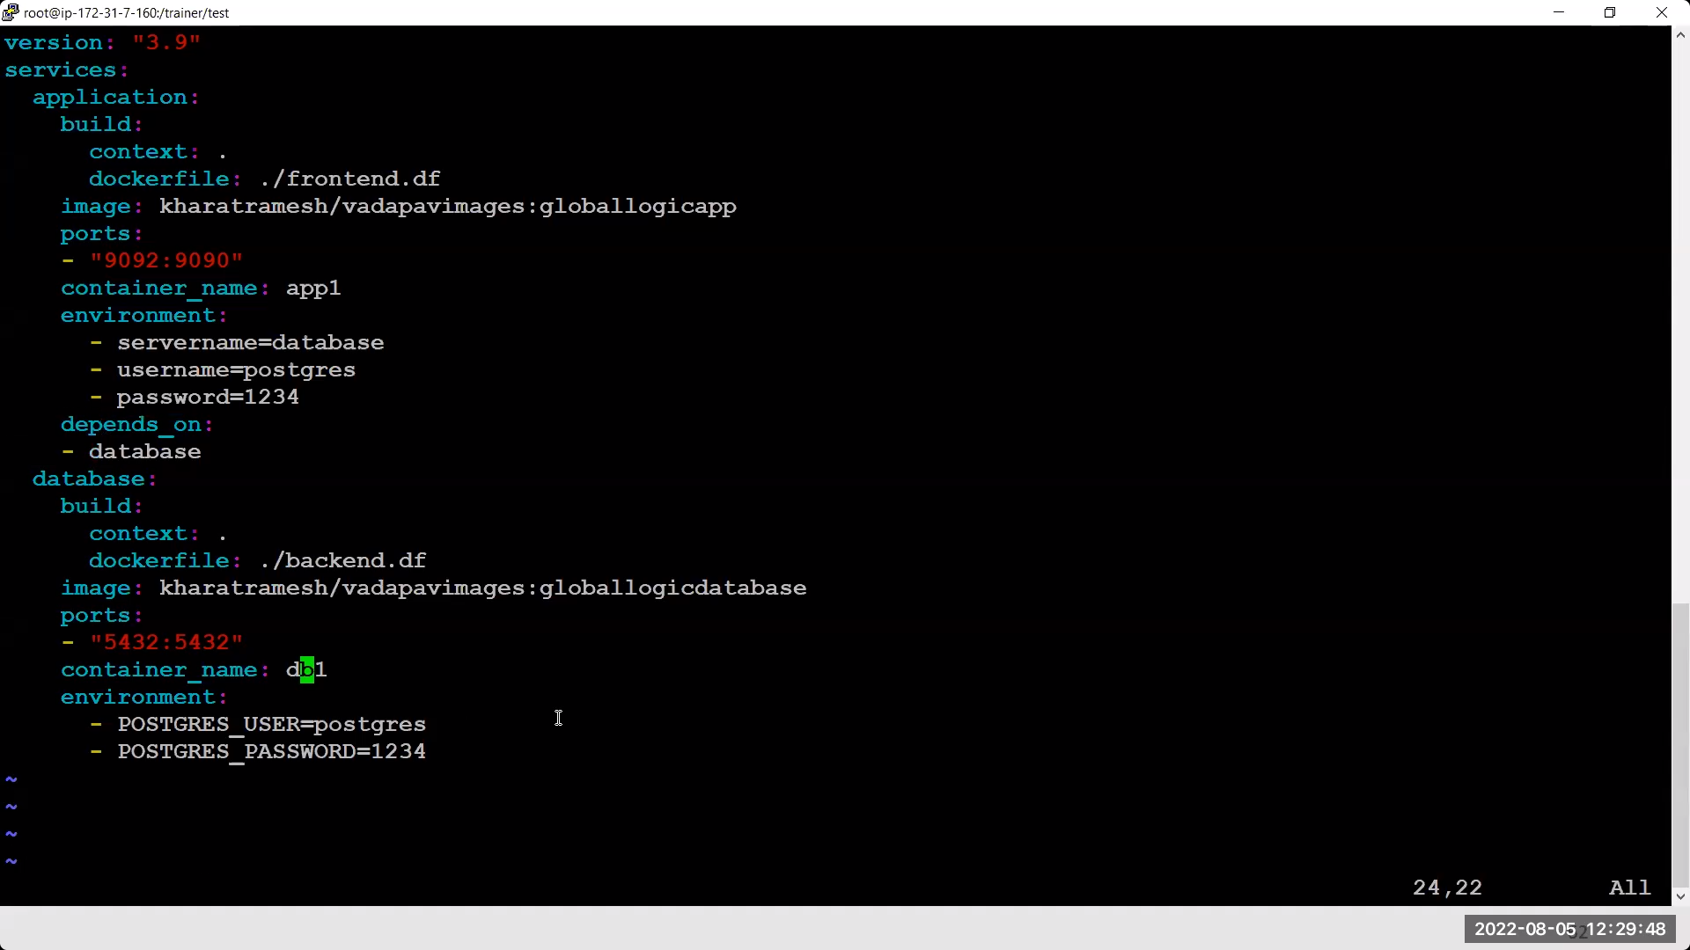

Above image is half

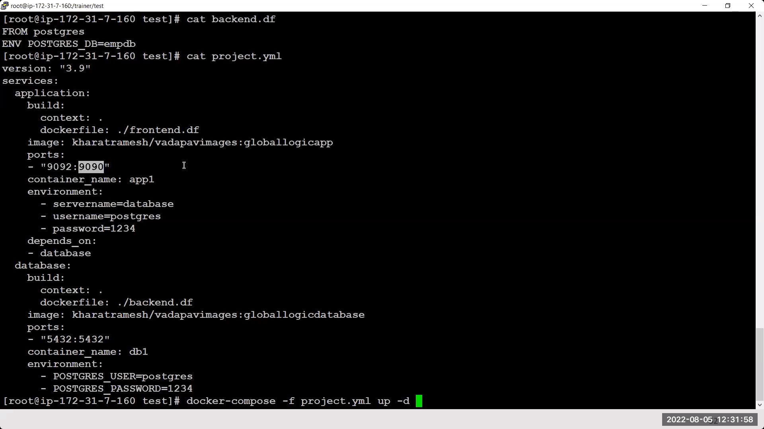

Above is full

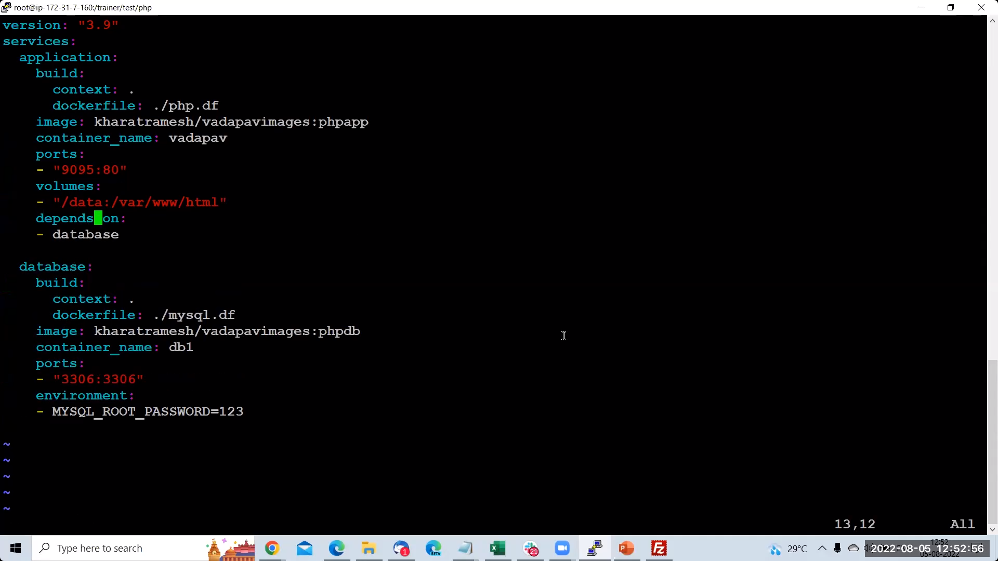

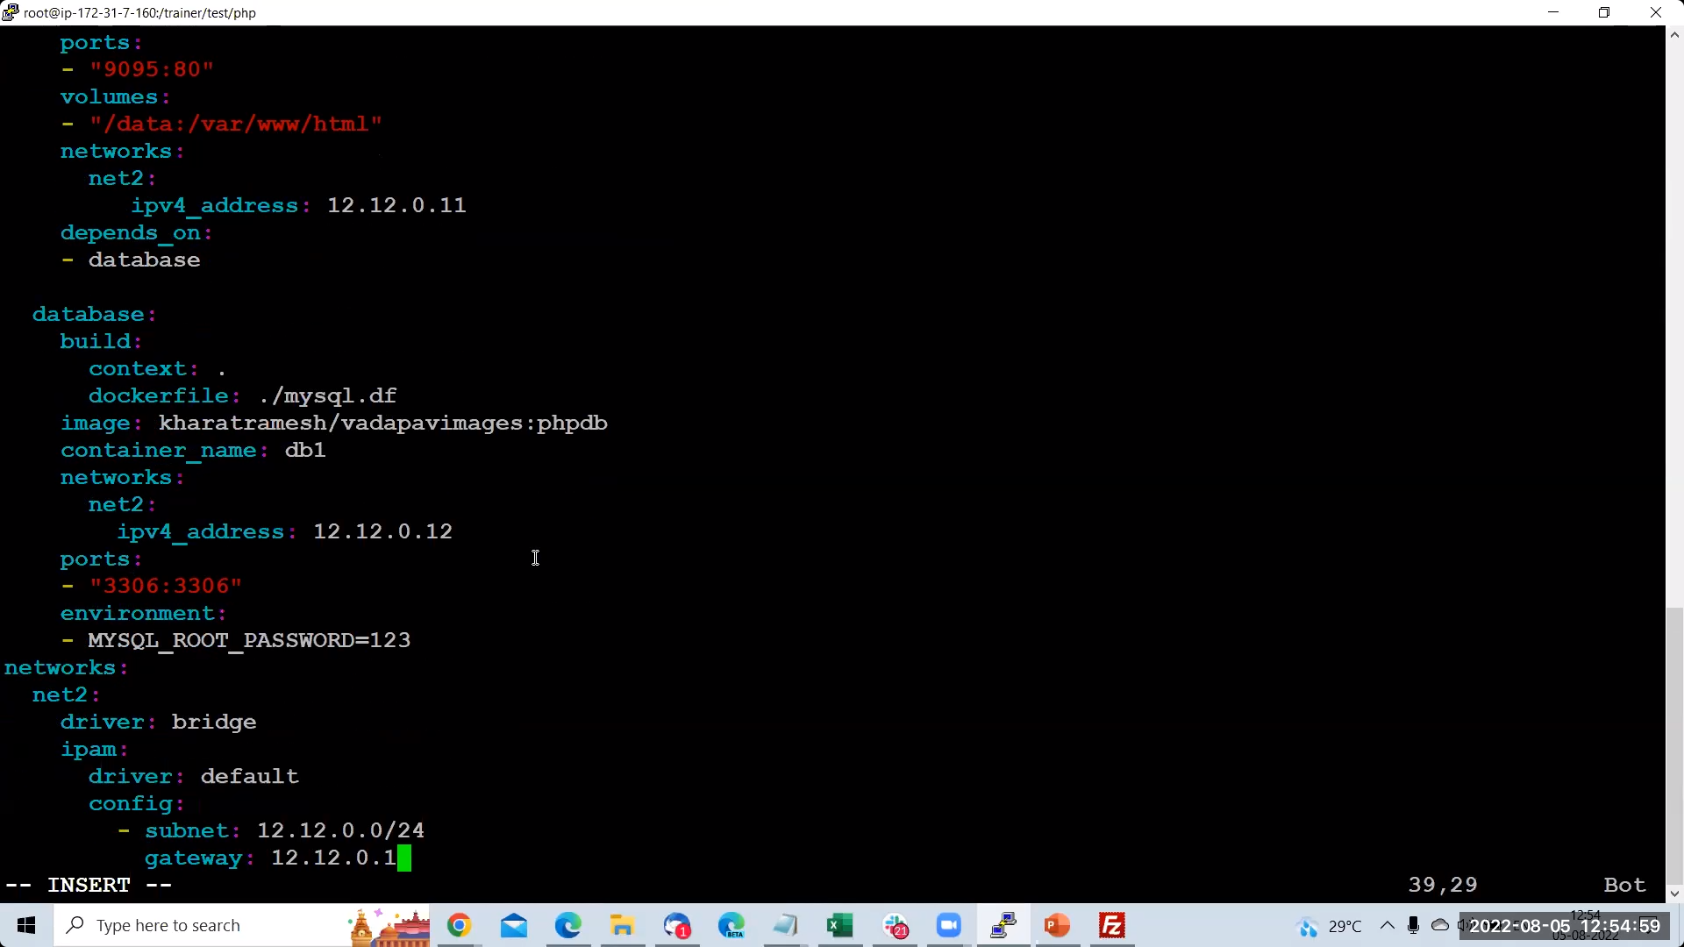

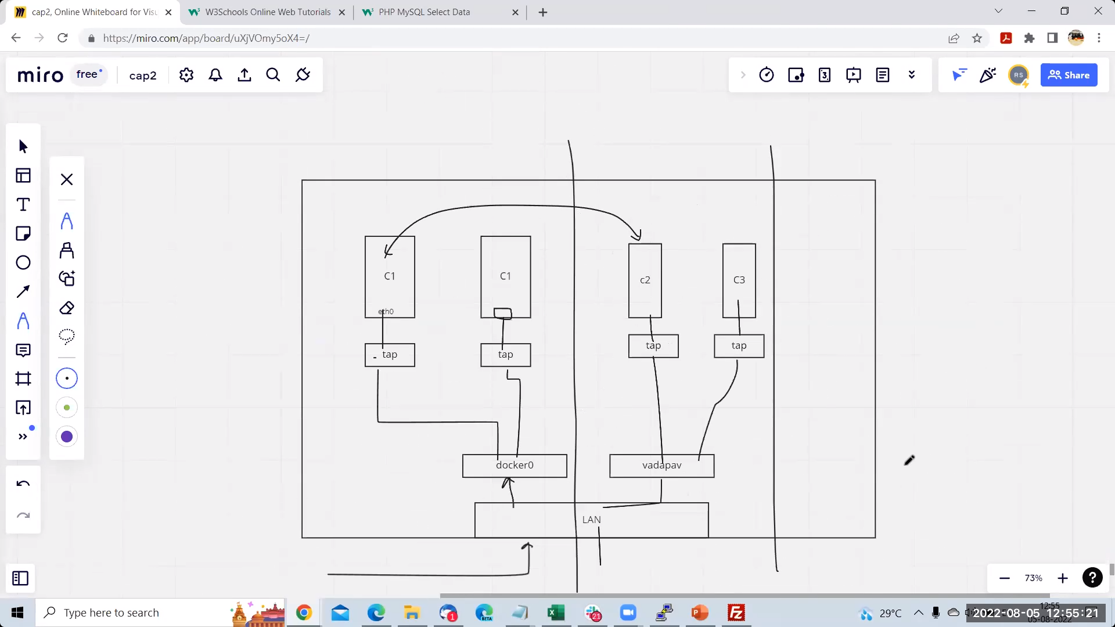

The above image show that when we are connecting to the container

First it enters into the our linux adapter which LAN [eth0]

Second From First it enters into the docker0 adapter [docker0]

Third From Second it enters into the Tap adapter which is container adapter [vnet]

And then acess the container

Evening:

OnBuild:

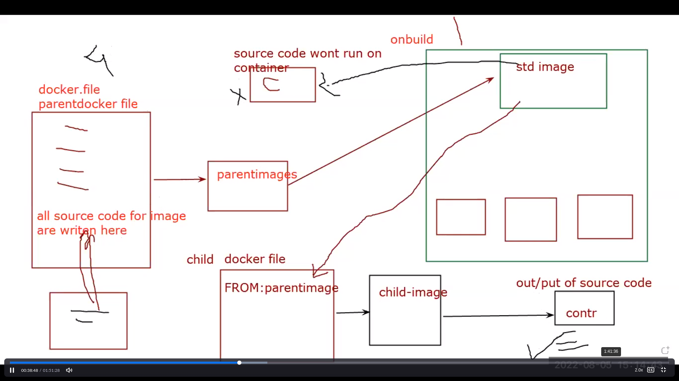

Onbuild is command where we don’t want to exceute souce code [like .java,.py,.sh files] while we creating container using parent image and want to excuete the source code with container which is created using child image[child is created using above parent image]

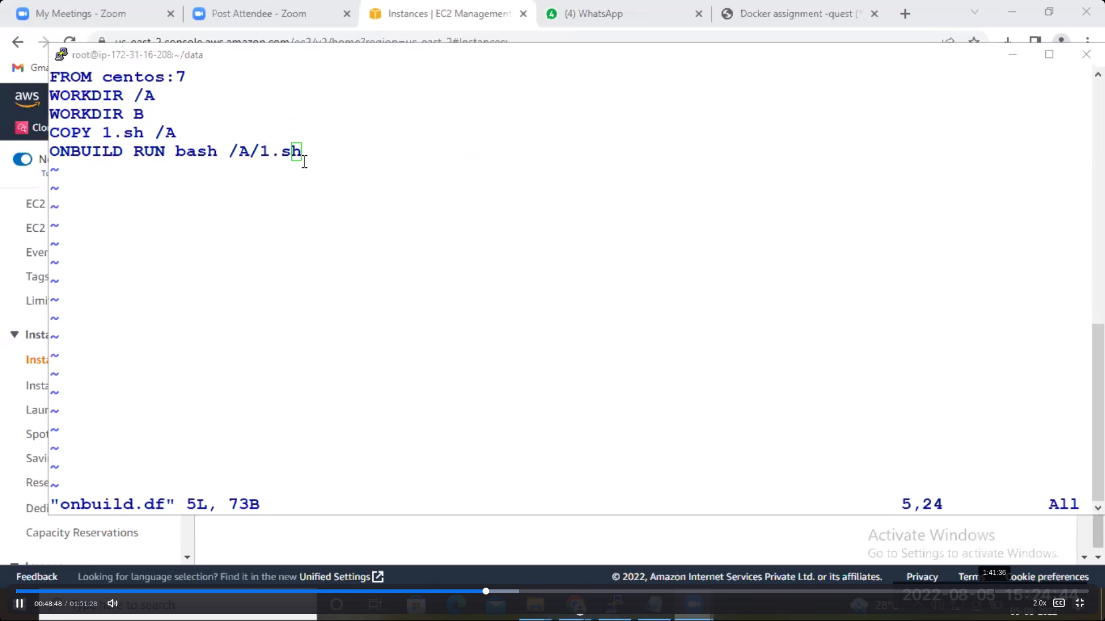

Parent image docker file

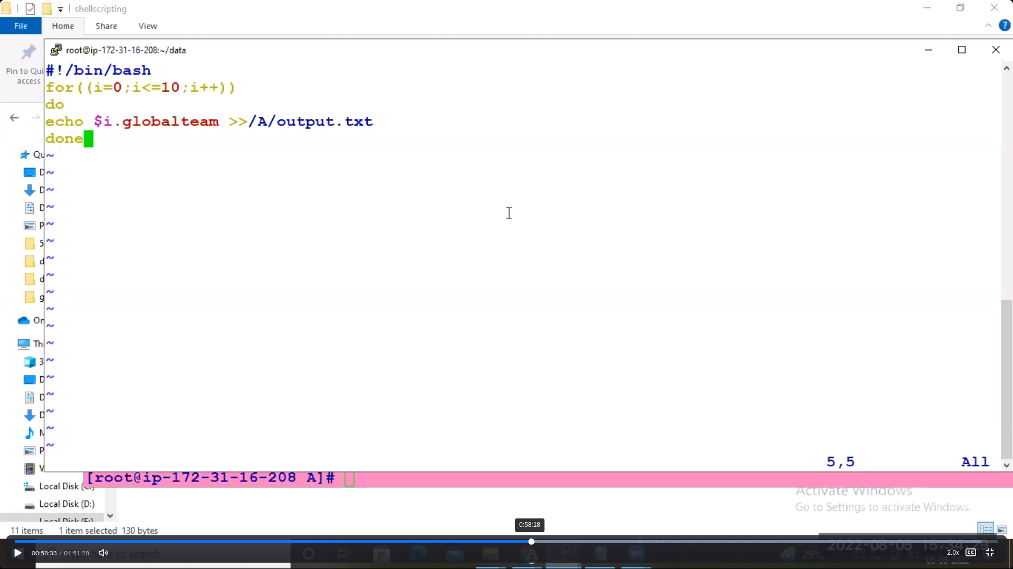

1.sh file

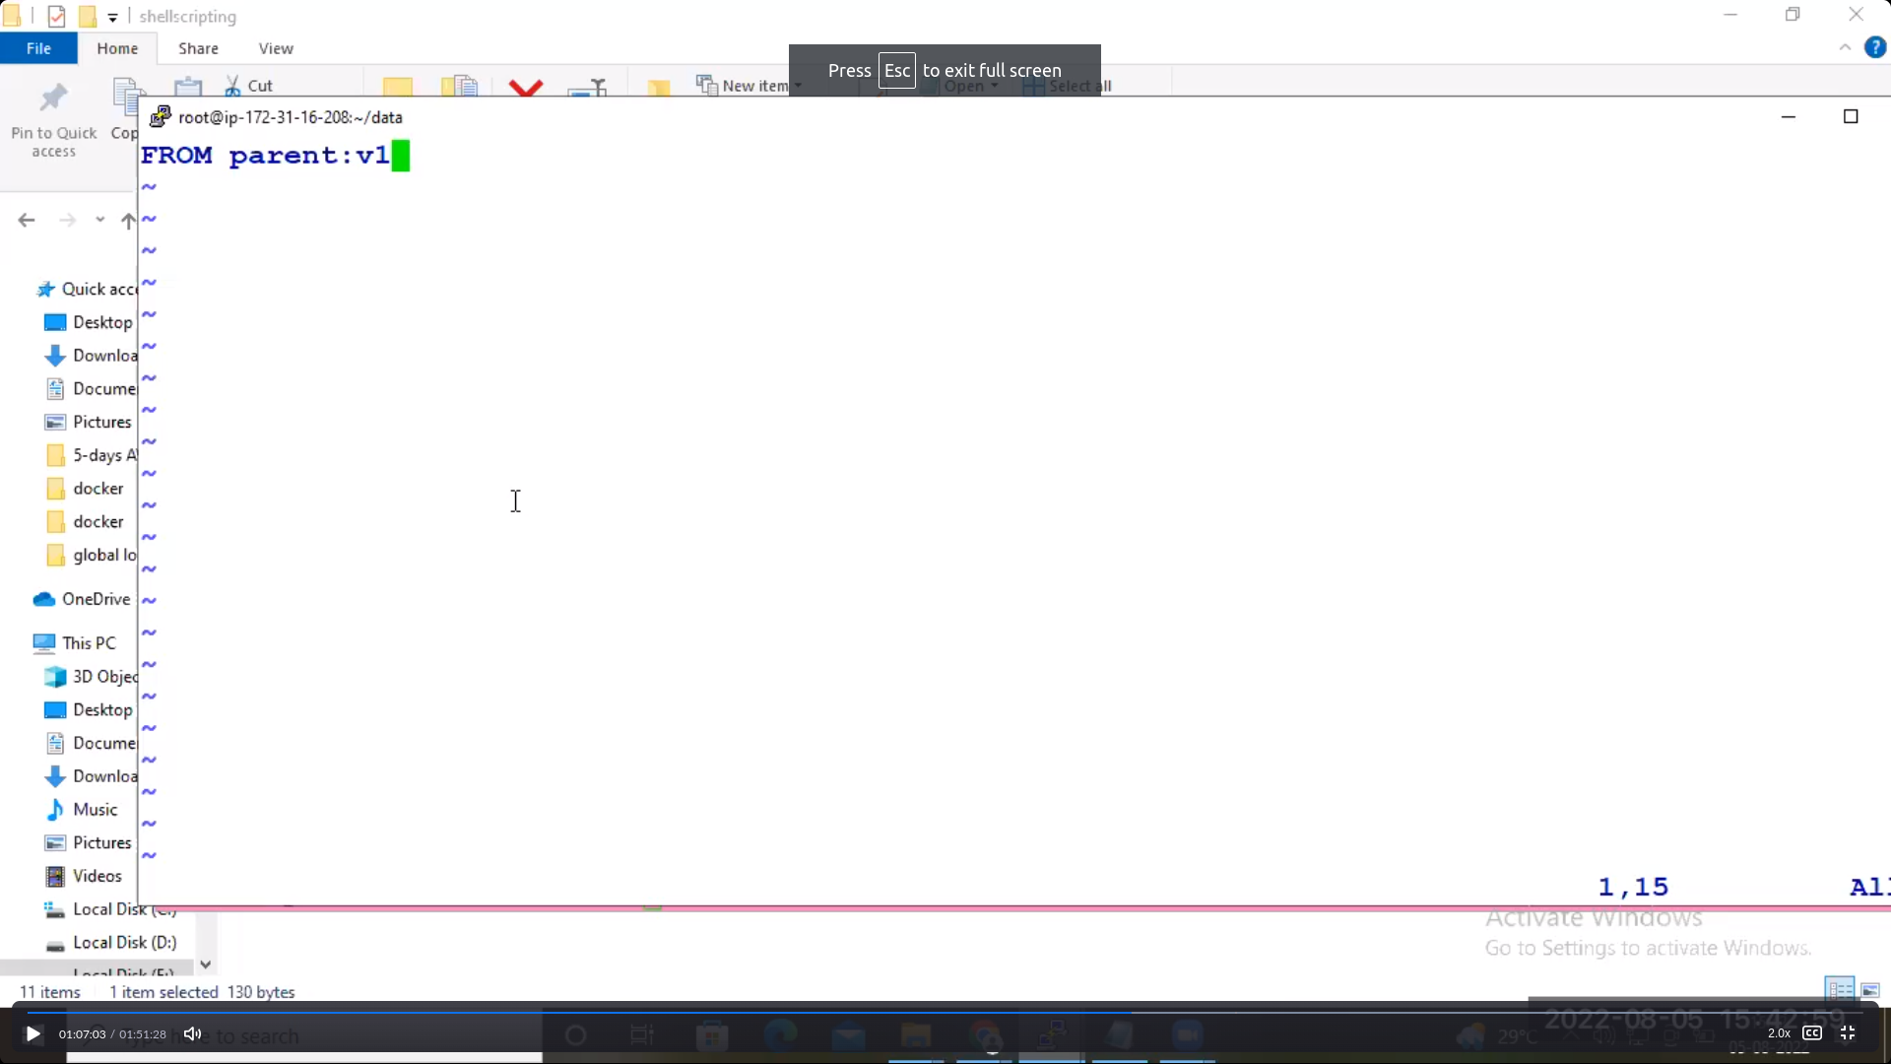

Child image docker file

Commands:

83 vi onbuild.df

84 vi onbuild.df

85 vi onbuild.df

86 vi 1.sh

87 vi onbuild.df

88 ls

89 docker build . -f onbuild.df -t parent:p1

90 docker ps

91 docker images

92 docker run -it -d --name mayo parent:p1 bash

93 docker ps

94 docker exec -it mayo

95 docker exec -it mayo bash

96 vi onbuild.df

97 docker exec -it mayo bash

98 #source code is not running on cont which is created from parent image99 vi child.df

100 vi 1.sh

101 vi child.df

102 vi child.df

103 docker images

104 vi child.df

105 docker build . child.df -t child:c1

106 docker build .-f child.df -t child:c1

107 docker build . -f child.df -t child:c1

108 docker images

109 docker run -it -d --name mayo2 child:c1

110 docker ps

111 docker exec -it mayo2 bash

112 ls

113 vi child.df

114 ls

115 docker ps

Explanantion:

The task is first we have to create a dockerfile for parentimage and after building the parent image

We will create a container using parent image .In the container 1.sh file should not be executed .

[83-98]

By using the above parent image we create another dockerfile for child image so after build image

We will a create a container image using child image . In this contaner 1.sh fiel shold be exceuted

[100-115]

This explanation tells ONBUILD command